Task: Networking Tasks

Submitted by:
Kashan Zulfiqar

Dated : 03/30/2026
- Tcp
Tcp protocol is used at trasport layer it sends data and waits for response .It also checks errors during data transfer. Before sending data it establishs 3way handshake with the receiver.

- Tcp dump
Tcp dump is used to monitor network traffic of all neetwork or a single device using
To check traffic on specific device
tcpdump -D command
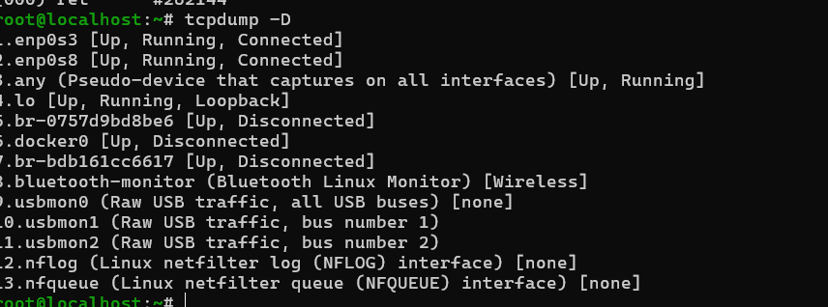
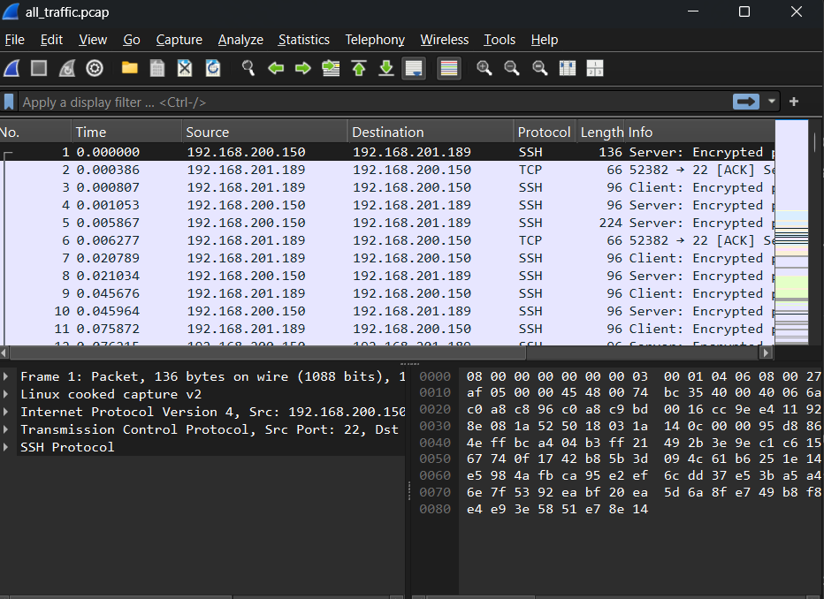

- http
Hyper text transfer protocol is used to send
http is a protocol that is like a letter or request sent to the server to ask for the required information or data the server in return sends the required data in the requird format to the client.

- Tcp
Transmission control protocol:-
Its like a postal service that does the actual data transfer between server to client. The http requests are sent through tcp. Tcp also does the segmentation if the data is big and it also manages error.
Tcp is like a mail server that handle the transfer of information from one server to client like a post man

- https
https is just secure version of http . first the tcp 3 way handshake the tcp asks the server if its available or not if its available it sends its public key and digital certificate the client upon receiving the certificate checks the authenticity from trusted authorities list. Then if the certificate is authentic the client sends a session key that is also encrypted with public key of the server then when the session key is received session is built and data transfer is started.

- Ssl
Ssl is a digitial id card for a domain.it is used to prove that the website domain is not fake.
SSL on nginx
For applying ssl on nginx site we use bwlow command
openssl req -x509 -newkey rsa:2048 -nodes -keyout website.key -out website.crt -days 365 \ -subj "/CN=website.net" \ -addext "subjectAltName=DNS:website.net,DNS:www.website.net,IP:127.0.0.1"
We have need .crt and .key file for ssl in nginx the .crt file is generated by csr file that is signed by using key file.
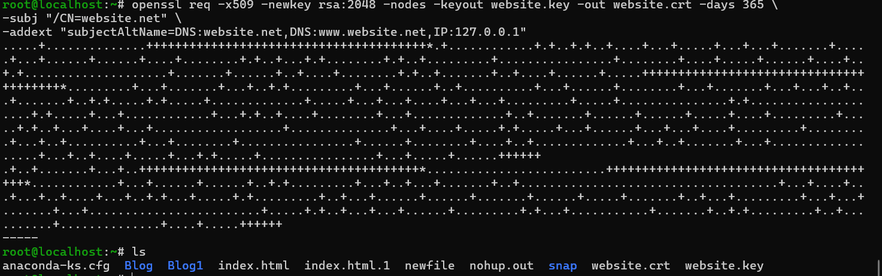
Now chang the address of the nginx to poin to these files .key and .crt
After that bring .crt file to windows and click on it and install it
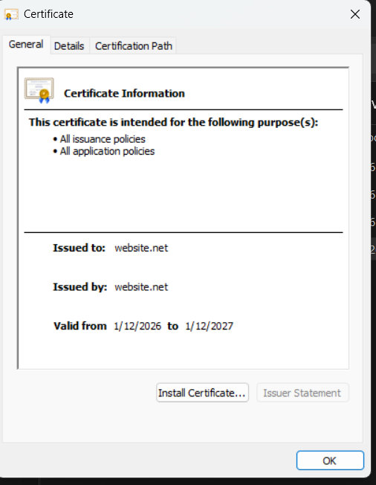
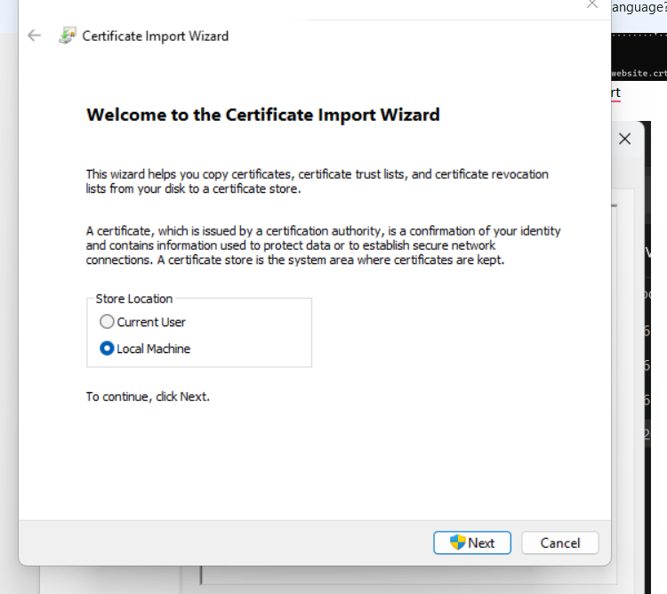

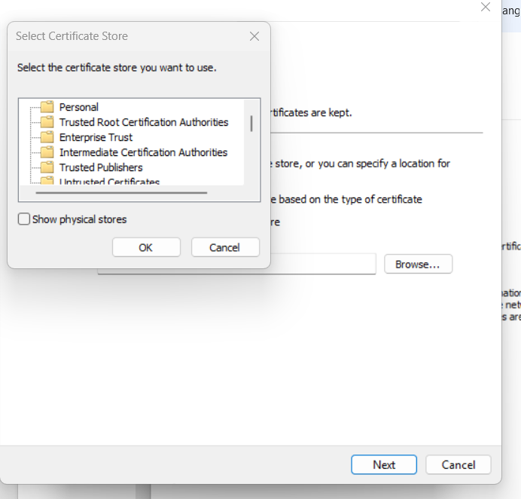
Now test
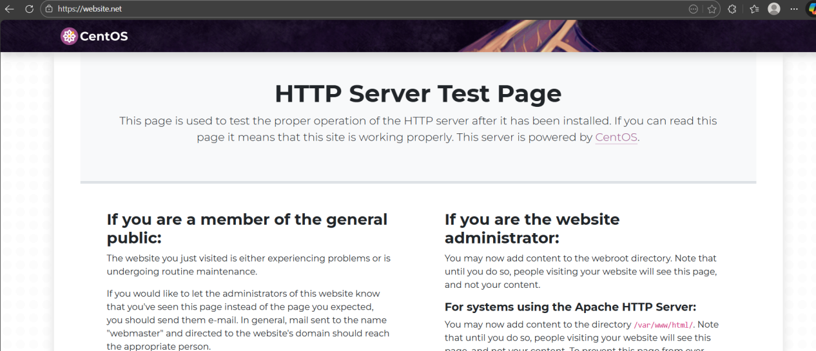

- Ip Subnetting:-
Ip subnetting is dividing a network to smaller networks according to requirement.

- Supernetting:-
Super netting is combining subnets into a big network.
Why do we do it? (The "Brain" Limit)
Routers have limited "brain power" (memory). Every entry in a Routing Table takes up space.

If a major router in New York had to remember the specific path to every single house in London, its memory would explode.
Instead, it uses Supernetting to remember one single entry: "If the IP starts with 192.16, send it to London." This keeps the routing table small and the router fast.

- Switching :-
It is the method of moving data from an incoming port to an outgoing port. It is the "logic" or the "math" of how to get a packet from Point A to Point B within a network.
- Vlans:-
Vlans are virtual lans with in a lan network . All the pcs are connected with a single switch but are logically divided in small vlans each vlan cannot send a data to the pc in another vlan .To communicate between vlans we use router .

- Truncking:-
It is a single physical cable that carries data for multiplee vlans without mixing them at the same time .It does not use ips for this purpose it uses the concept of tagging it tags every message so the messagee does not gets mixed.

- Ip pooling:-
Ip pool is a range of ips that a DHCP can assign to devices when a device requests.
Example: A router might have a pool from 192.168.1.50 to 192.168.1.150. When you connect your phone, the router "leases" one address from this pool to your device.
- Routing :-
Routing is finding the right network .it looks at the ip address to check which path the ip address should follow to reach the destination.
Practical for routing switching and vlans
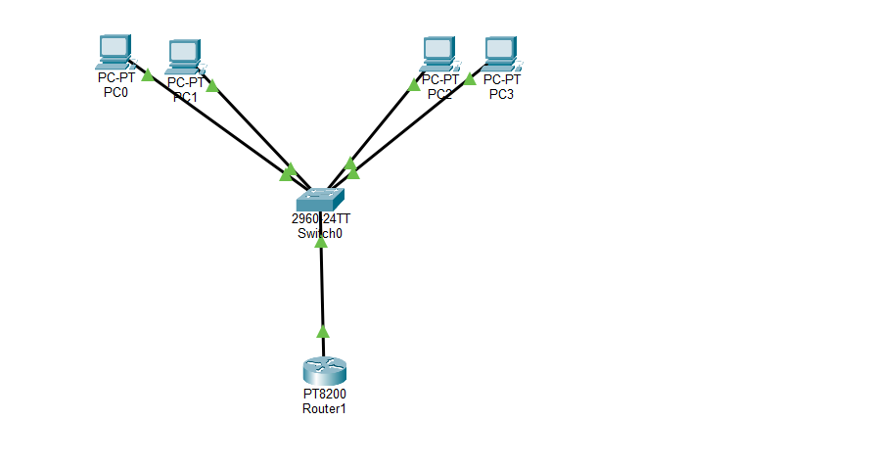
Before vlan configuration pc 0 is able to communicate with pc 2
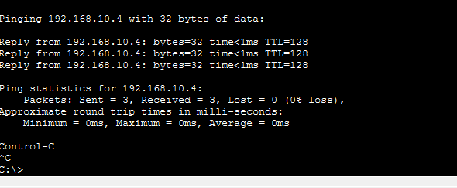
After vlan configuration

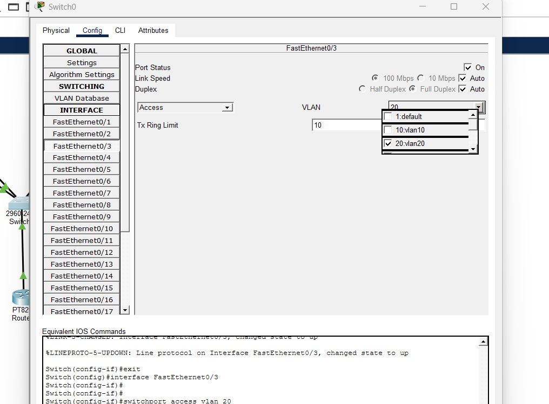
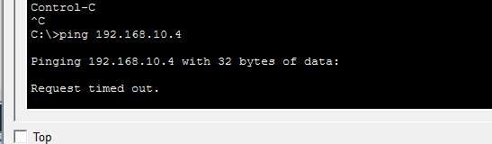
Now to allow 2 vlans to communicate we will add a trunk cable with a router.
After that we will assign different network to the vlan2 pcs because router works on 2 different networks not in same .below screen shot shows communication between 2 different vln pcs.
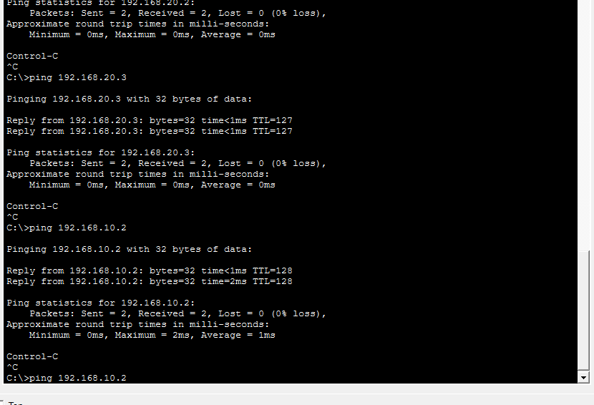
- Stp:-
Spanning tree protocol
It’s a protocol inside switch that prevents the loops which can occure if there are redundent cables and 2 switches are attached together.
- Ip table:-
Iptable is the command line to give instructions to netfilter that is the part of linux kernal that actually manages the access.
- ACls:-
Access control list that is a digital guest list that is used by router and switches to decide which data packets are allowed to pass and which shouldbe blocked.
- Dns:-
Domain name service translates domain names like google.com to ip like 192.168.56.1 human friendly name to machine friendly name.
- HA proxy:-
High availability proxy is a open source load balancer that is used to balance load between multiple servers based on technique like round roubin.
It is a opeen source software for lod balancing .
It has 3 parts
1 front end ip of ha proxy
2 backend servers on which load is balanced based on requests.
3 the algorithm by which the load is balanced like round roubin and least connct etc.
Installation:-
Usee yum install haproxy -y to install haproxy
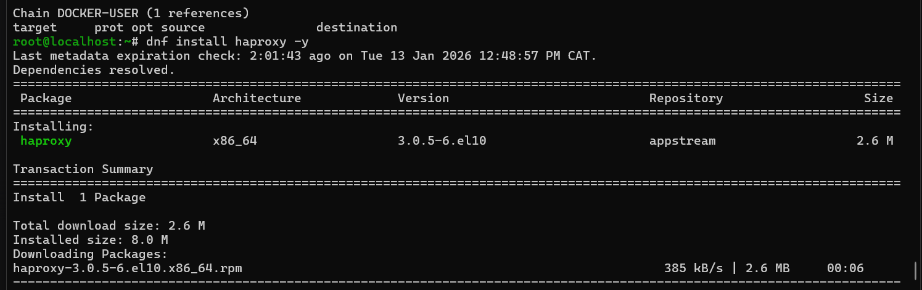
Main configuration file is
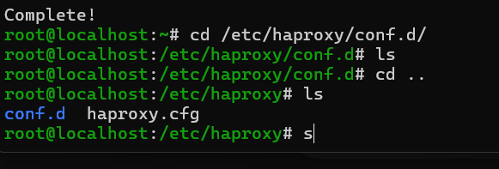
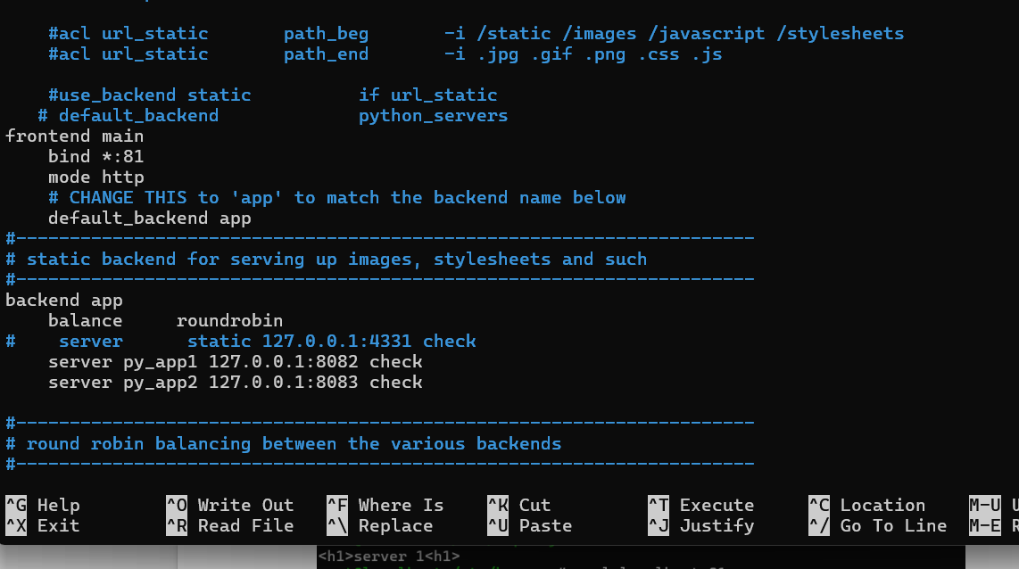

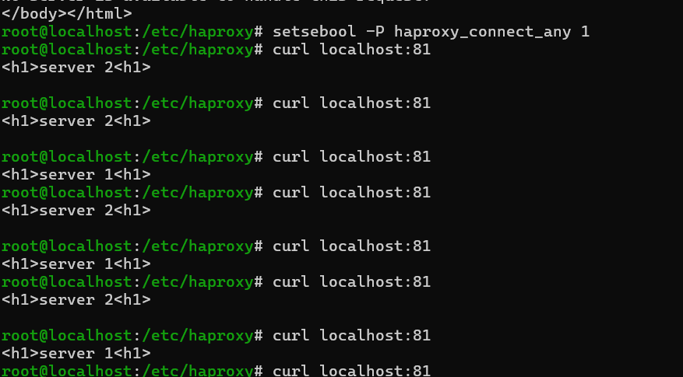

- Nginx reverse proxy:-
Nginx reverse proxy is used for hiding the server ip the requests are sent to the nginx port and nginx accesses the backend server .
- Firewall :-
Firewall is a security barrier that can be used to block ips that accesses system or if we want to allow only a specific ip to access the server .
- Nat:-
Network address translation it allows multiple devices in our houses to share same public ip to access the internet. The devices can access the internet using public ip assigned by isp but no one can access the devices from out side without knowing the port that is assigned by the router to each device.
- Nv :-
Network virtualization is taking physical harware of a network like router switch and managing it at abstract level like making vlans in a switch .
In below screen shot we can see the pcs are connected to switch but we have divided it in 2 different virtual lan networks. Now they cannot communicate with each other.

Before vlan configuration pc 0 is able to communicate with pc 2

After vlan configuration



- Ip sec vpn :-
IPsec (Internet Protocol Security)
an IPsec VPN is like a secure, armored tunnel built through the public internet.It is used to connect entire networks together. It is useful if we want to connect 2 offices togetter and perform secure data transfer.
- Ssl Vpn :-
Ssl vpn is an SSL VPN is like a secure, private room you enter through a web browser.It uses the same technology (SSL/TLS) that protects your bank's website (the "lock" icon in your browser address bar) to give you secure access to your office or home network.
It uses the same technology (SSL/TLS) that protects your bank's website (the "lock" icon in your browser address bar) to give you secure access to your office or home network.

2. Tunnel Mode (Thin Client)
If you need to use software that isn't a website (like Remote Desktop or a database tool), you use Tunnel Mode.
How it works: You download a tiny, lightweight app (like Cisco AnyConnect or FortiClient).
The Result: This app creates a virtual network adapter on your computer, making it feel exactly like you are sitting in the office, but it still uses the SSL/TLS protocol to stay secure.

Osi Model vs Tcp/ip model:-
The OSI (Open Systems Interconnection) model was created to be a universal, theoretical framework for all computer communications. The TCP/IP model, however, was developed specifically for the ARPANET (the early internet) and is the practical protocol suite we use today.
OSI is a reference model used for teaching and troubleshooting. TCP/IP is a functional model that contains the actual protocols that make the internet work.
Layer Comparison

OSI Layer | Name | TCP/IP Equivalent | Function
7 | Application | Application | Human-computer interaction (HTTP, FTP, DNS).
6 | Presentation | (Merged into Application) | Data encryption, formatting, and translation.
5 | Session | (Merged into Application) | Maintaining and terminating "conversations."
4 | Transport | Transport | End-to-end delivery (TCP vs. UDP).
3 | Network | Internet | Routing packets via IP addresses.
2 | Data Link | Network Access | Moving data between two physical nodes (MAC addresses).
1 | Physical | (Merged into Network Access) | Hardware, cables, and electrical signals.

